John Michael Go
Career Entry Level Java Programming
Date: Jan. 14, 2013

DAY 2

Program Name: OddEven

Objective: Program determines if number is odd or even.

Algorithm:

- User inputs number.
- Program determines if number is odd or even.

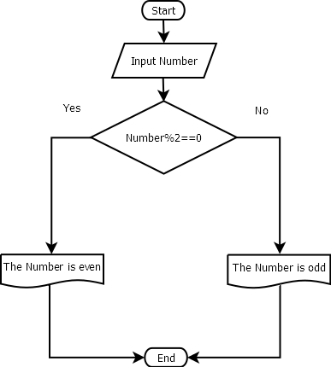
Flowchart:

Pseudocode:

import java.util.*;
import java.io.*;

public class OddEven{

static Scanner console = new Scanner (System.in);

public static void main(String[]args){

int num;
System.out.println ("");
System.out.print ("Enter Number: "); // input number
num = console.nextInt();
System.out.println ("");

if (num%2==0){
// if number is even
System.out.println ("");
System.out.print ("The number you have entered is even");
System.out.println ("");
System.out.println ("");
System.out.println ("");
}else{
// if number is odd
System.out.println ("");
System.out.print ("The number you have entered is odd");
System.out.println ("");
System.out.println ("");
System.out.println ("");
}

}

}

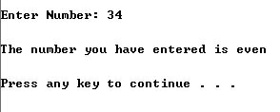
Screenshot:

